Online Disclosure & Barring Service (DBS)

Applicant’s Guidance: Completing an Online DBS Application

|  |
| --- |
| **Introduction** |

Strictly Education 4S Ltd acts as an ‘umbrella body’ in processing DBS (formerly CRB) applications for the school/organisation you will be working for. In order to process your DBS check you have been asked to use our online system. This system provides a more efficient, accurate and secure alternative to the completion of paper DBS application forms, however, if you are unable to complete your DBS application online, please speak to your appointing school/organisation to discuss other alternatives.

**The following guide will help you to complete your online application. Please retain this information as you may need to refer to it later.**

An online DBS check can be completed by accessing the internet from any device that has this facility. This includes a smart phone, tablet, laptop or PC. It is supported on the latest versions of all modern browsers; however, we do not recommend access via Internet Explorer.

All individuals requiring a DBS certificate must complete a DBS application form and contact the school/establishment to arrange a meeting in person so that your identity can be checked.

This guidance tells you about:

* How to complete the online DBS application
* What documents are required to check identity
* Who checks identity
* What happens next
* Data protection
* Further information

|  |
| --- |
| **How to complete the online DBS application form** |

The school /organisation have requested that you apply for a DBS certificate by accessing the following website address using the unique reference and password details below:

|  |  |
| --- | --- |
| **Website Address:** | [**https://disclosure.capitarvs.co.uk/strictlyeducation4s/**](https://disclosure.capitarvs.co.uk/strictlyeducation4s/) |
| **School / Organisation Reference:** | **9363024** |
| **Organisation Code:** | **STA1860 (case sensitive)** |

After you have accessed the online DBS application system using the above website address, move the cursor onto the **Start Application** and **click** to enter system.

The system will then require you to **Start New Application** –

Please enter the Organisation Reference and Password (if you have been provided with one) and press start button.

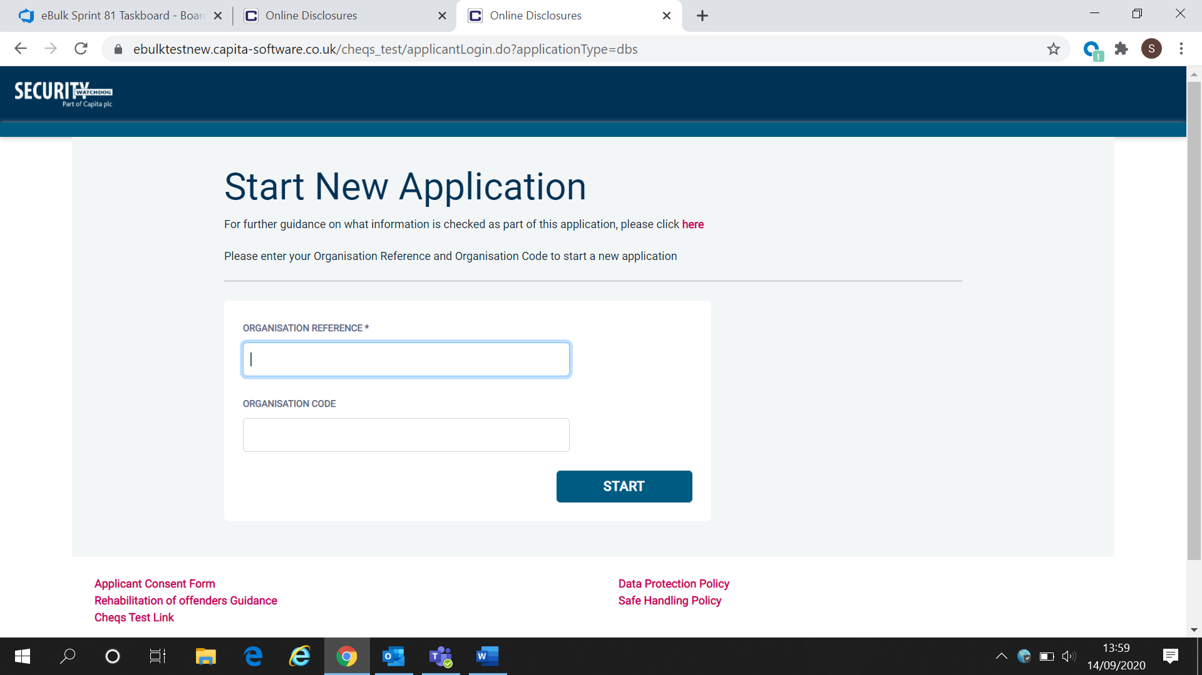

|  |
| --- |
| **Statement of Fair Processing** |

You will now be taken to the ‘Statement of Fair Processing’ outlining the terms and conditions for processing.

Please read the statement and tick the box to confirm this has been read and agreed to and click ‘Next’.

|  |
| --- |
| **Application Pre-Entry Statement** |

You will now see the application pre-entry statement; this gives concise information regarding the DBS’s acceptable identification requirements in support of your application.

Once you have read the statement and ticked the consent box please click ‘Next’.

**Transgender Process**

DBS offers a confidential checking process for transgender applicants.

This process is for transgender applicants who do not wish to reveal details of their previous identity to the person who asked them to complete a DBS application.

For more information about the transgender process please email [sensitive@dbs.gov.uk](mailto:sensitive@dbs.gov.uk)

**Third Party Details**

If you are completing the application on behalf of someone else, please ensure you answer **‘Yes’** to the first question within the **‘Third Party Details’** section. Please then provide your personal details within the **‘Third Party Details’** section but the details of the person you are completing it on behalf of, for the rest of the application.

|  |
| --- |
| ***Section 1 – About You*** |

The application form is a simple 5 step process.

Please complete all fields. Mandatory fields are denoted by (*)

If you have any **middle name(s)** ensure that you **enter** these details, particularly those that appear on your identity documents.

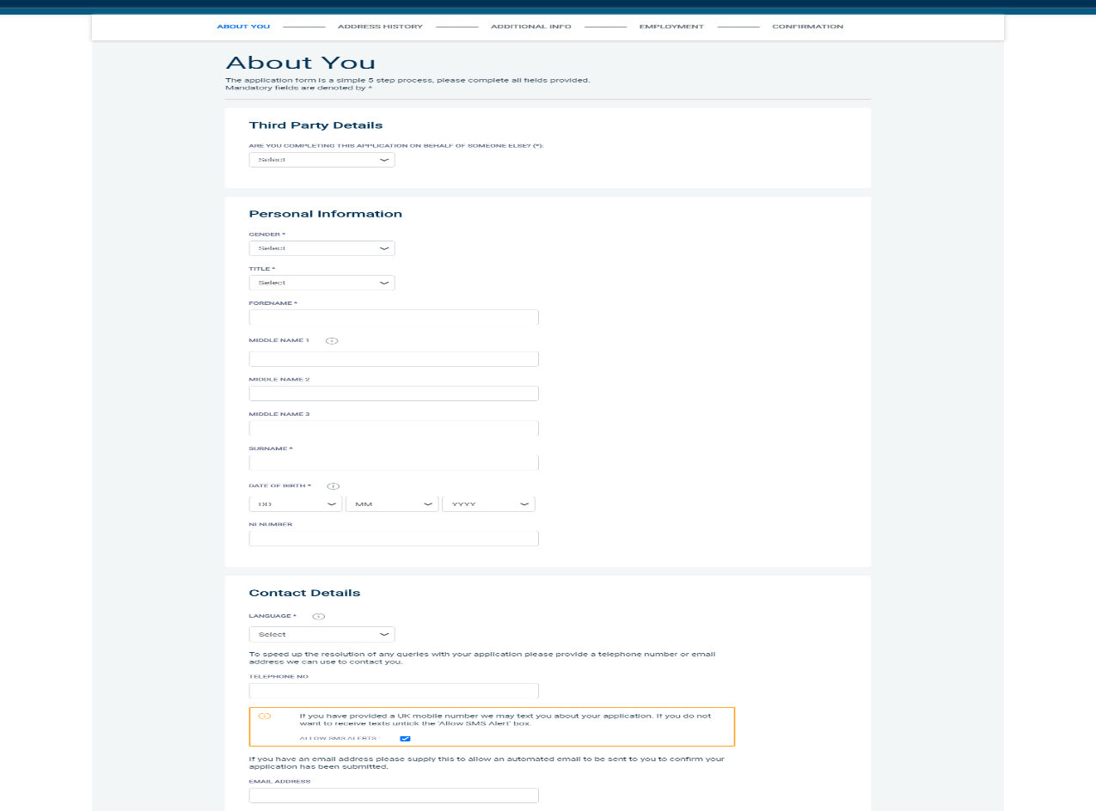

Mandatory fields are denoted by *

**Contact details:**

*Select **English**.

Insert your telephone/email address

**Email Address:**

Applicants should provide an email address as part of their contact details. This will enable you to receive an email directly from DBS confirming your Application Reference number. The email will also include links to the DBS website giving you the option to track the progress of your DBS application.

|  |
| --- |
| **Section 2 – Address History** |

Please enter your current address. If you have not lived at this property for more than five years, you will be taken to another screen. Here you will be required to add any additional addresses to ensure your address history goes back the required five years. Please note if you do not provide a minimum of five years address history, you will not be able to proceed to the next stage of the application process.

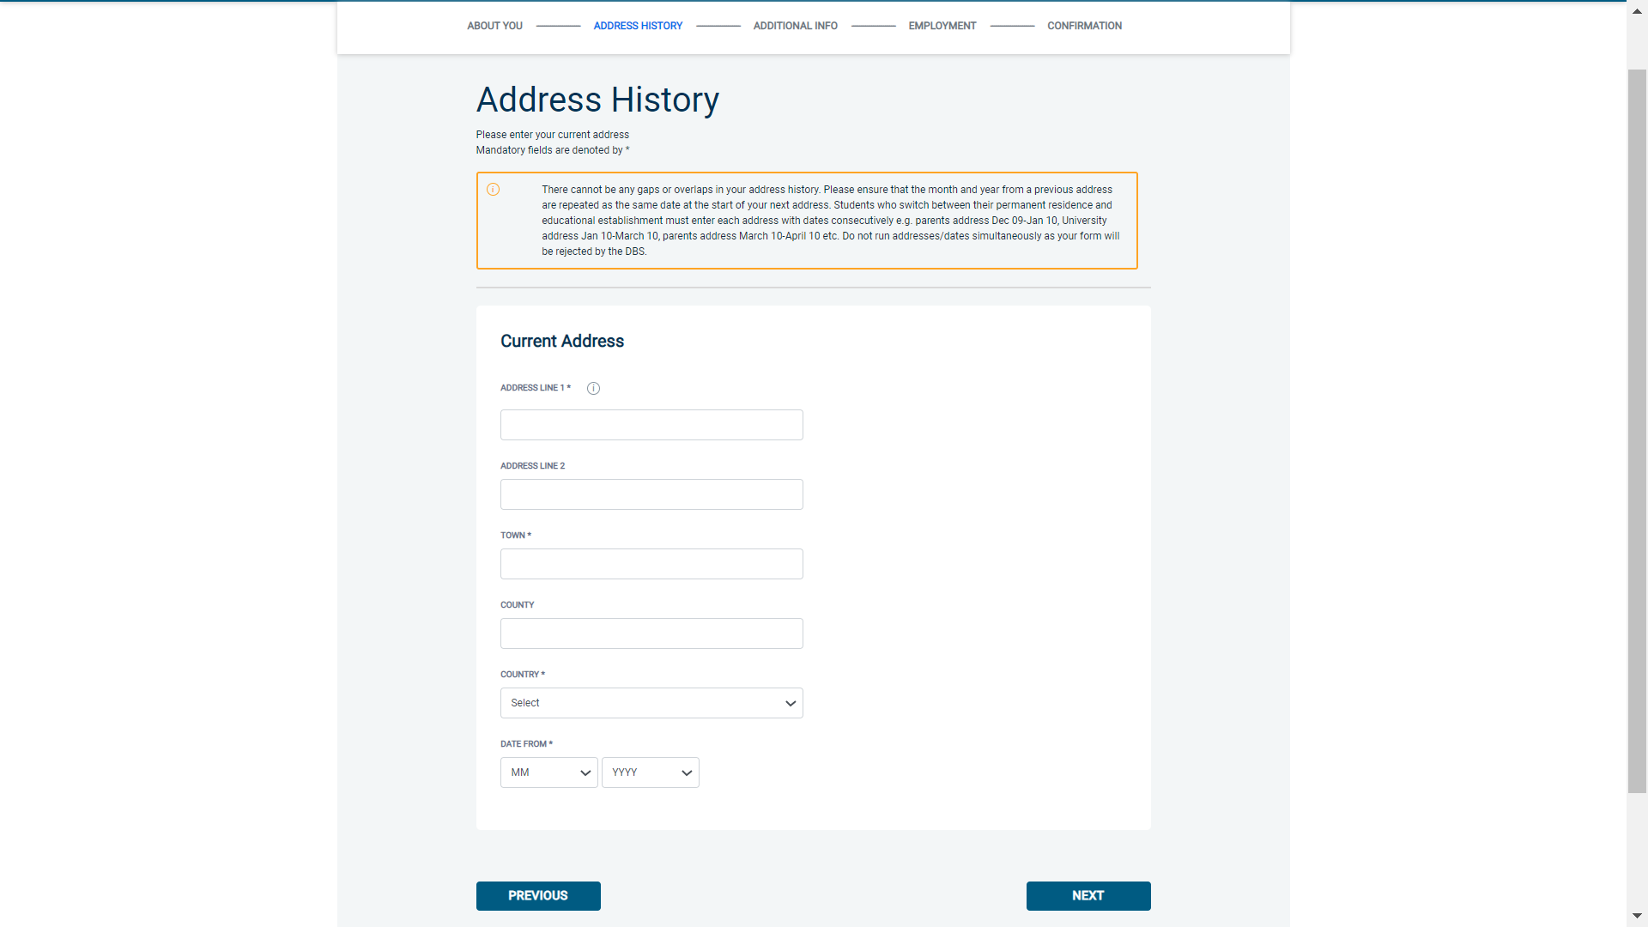

Address Dates

There cannot be any gaps/overlaps in your address history. Please ensure that the month and year of each address follows that of the previous address.

Students who switch between their permanent residence and education establishments must enter each address with dates consecutively, e.g. parents’ address Dec 2009 – Jan 2010, university address Jan 2010 – March 2010, parents’ address March 2010 – April 2010 etc. Do not run addresses/dates simultaneously as your application form will be rejected by the DBS.

Once an address has been entered, you can edit any information by clicking on the ‘Edit’ button. For further guidance visit <https://www.gov.uk/government/publications/dbs-unusual-addresses-guidance/dbs-unusual-addresses-guide>

Postcode

Please ensure that all UK addresses have a full postcode; if you cannot remember your postcode please use the Royal Mail link provided within the address information box <https://www.royalmail.com/find-a-postcode>.

No Fixed Abode UK

If you were of no fixed abode within the UK please enter the nearest hostel address to the location you were based.

Foreign Addresses/Travelling Overseas

If you have travelled overseas and cannot supply the address for a foreign country then please enter ‘no fixed abode’ for Address Line 1. Please then enter the Town/City and Country of where you were residing within this period.

Once you have completed this section click ‘**Next**’.

|  |
| --- |
| **Section 3 – Additional Info** |

**Place of Birth:**

Please enter details of your place of birth.

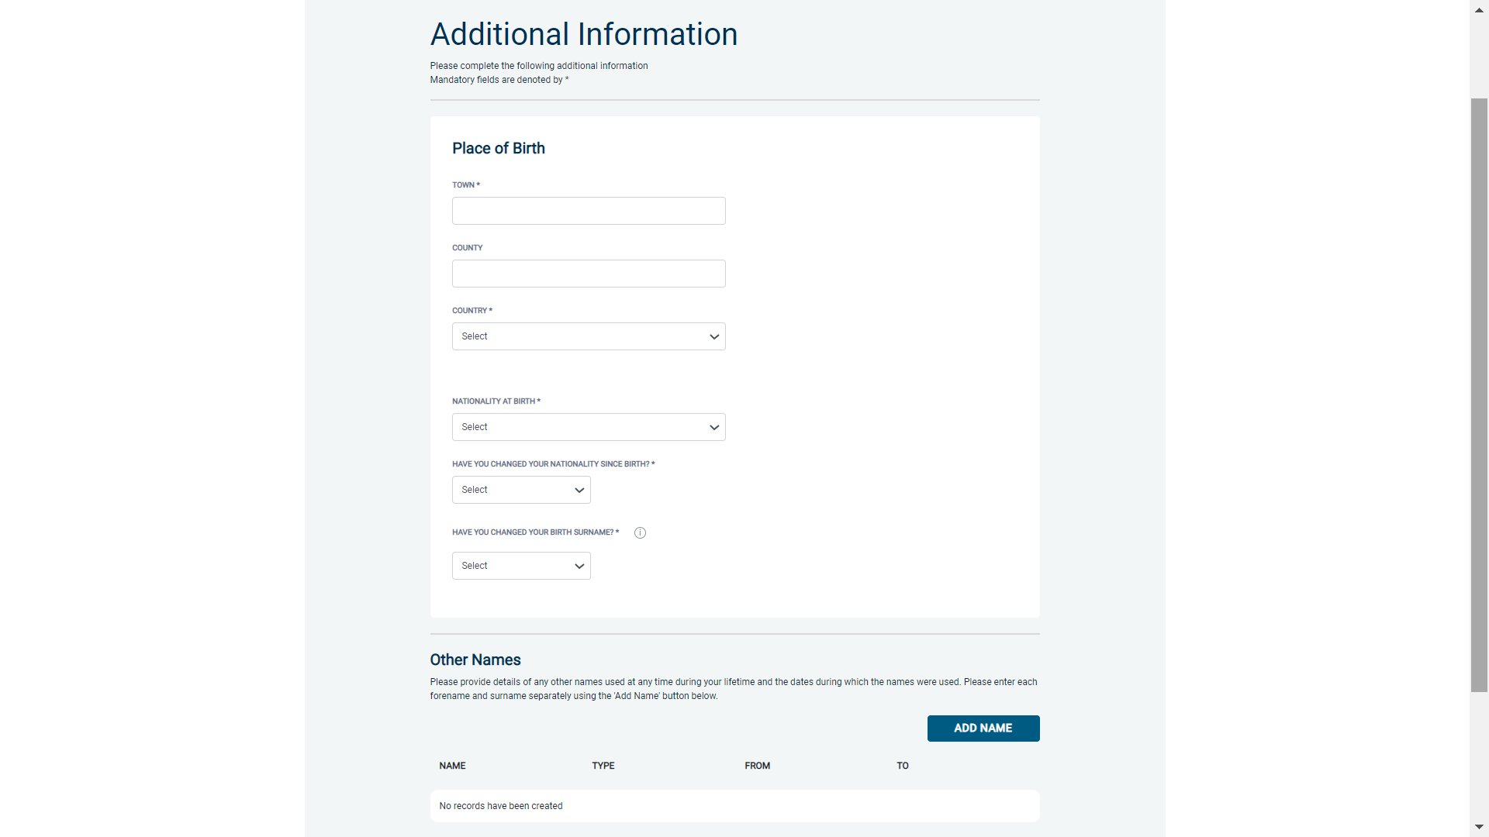

Nationality at Birth

Please enter your Nationality at birth and state YES or NO as to whether this has changed since you were born. If this has changed, you will be required to enter your current nationality.

Changed Surname

If you have changed your surname please provide your birth surname and the year you changed it. Please ensure that where names change they run in date order and with no gaps.

You will be asked to **provide documentation to support change of name i.e. Marriage Certificate/Civil Partnership Certificate etc.**

Applicants who were adopted before the age of 10 do not need to provide their surname at birth when completing an online application. **Applicants should give their adoptive name in this section**.

Other Names

Please provide details of any other names used and the dates during which the names were used.

Enter each **forename** and **surname** separately including **Aliases** using the **‘Add Name’ button**.

Failure to supply any additional information may cause your application to be delayed.

Once you have completed this section click ‘**Next**’.

|  |
| --- |
| **Section 4 – Employment Details** |

Position Applied For

Please insert the correct job role as supplied to you by your current/new employer/establishment. You will either be required to select your job role from the dropdown list provided or enter this manually. No abbreviations are permissible, e.g. Admin Asst should read School Administrative Assistant. If you are a volunteer do not enter just volunteer, please enter in which capacity your job role is, e.g. School Helper.

Failure to enter the correct job role may cause your application to be delayed.

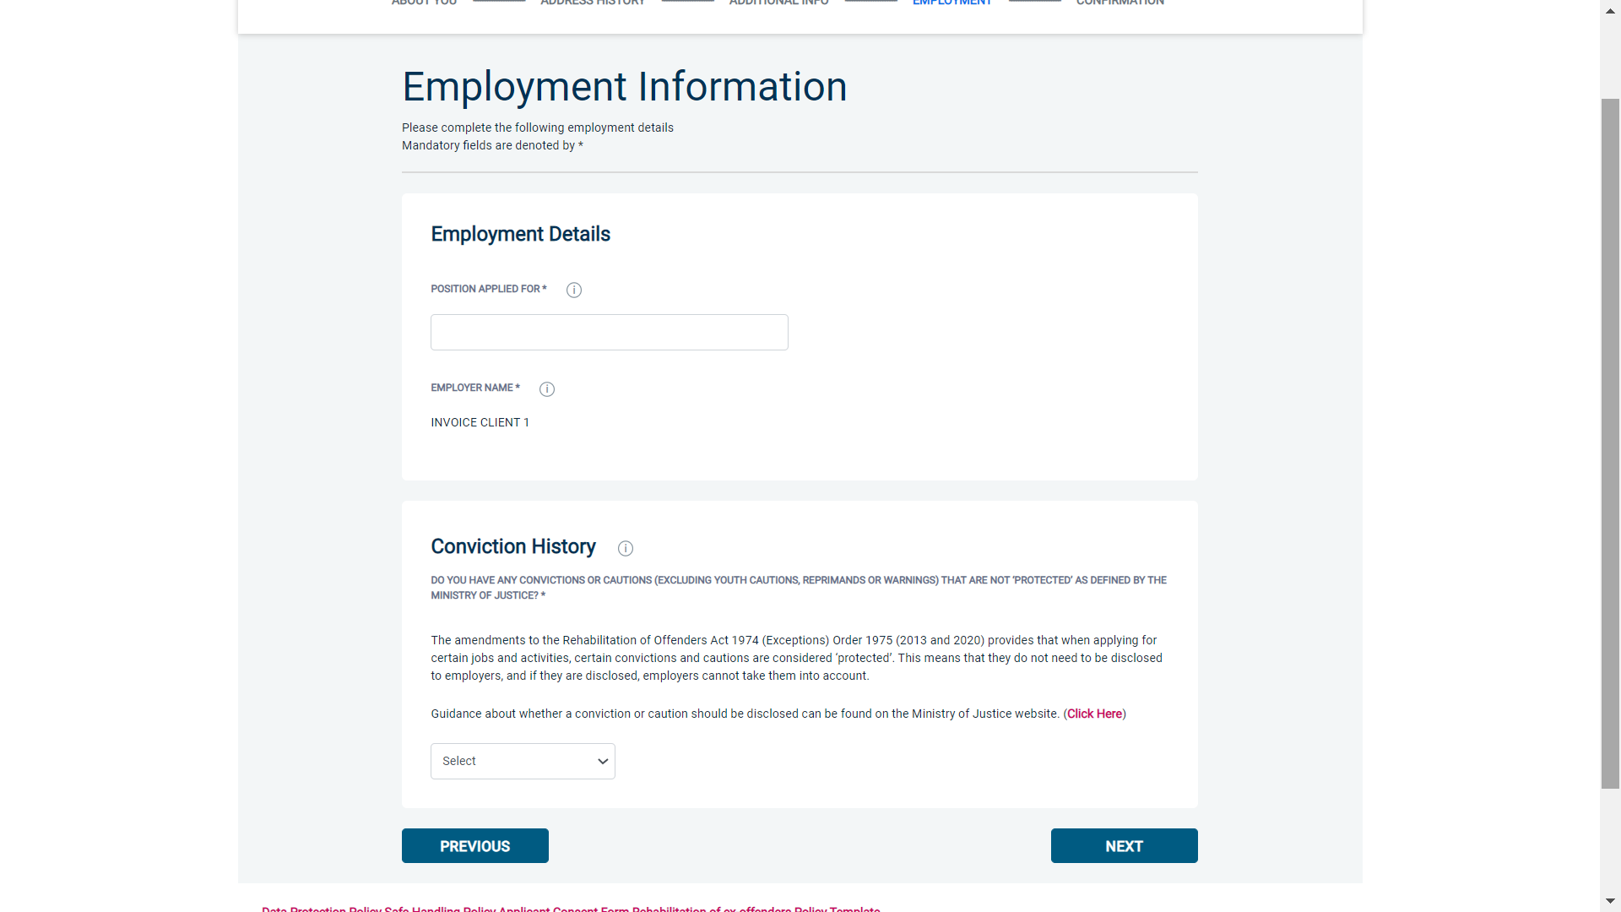

Conviction History

If you have **never** been convicted of a criminal offence or received a caution, then please select ‘**No**’.

If you have been convicted of a criminal offence or received a caution (excluding youth cautions, reprimands or warnings) that **is** ‘protected’ as defined by the Rehabilitation of Offenders Act then please also select ‘**No**’.

If you have ever been convicted of a criminal offence or received a caution (excluding youth cautions, reprimands or warnings) that **is not** ‘protected’ as defined by the Rehabilitation of Offenders Act then please select ‘**Yes**’.

For more information, please refer to:

[**https://www.gov.uk/government/publications/new-guidance-on-the-rehabilitation-of-offenders-act-1974**](https://www.gov.uk/government/publications/new-guidance-on-the-rehabilitation-of-offenders-act-1974)

Once you have completed this section click ‘**Next**’.

|  |
| --- |
| **Section 5 – Application Confirmation and Consent** |

Please review the details entered and click the **edit** button if you wish to change any of the information.

Now Tick the **consent boxes** at the bottom of this page.

(By ticking these boxes you are giving your consent for a DBS check to be undertaken, for an electronic result to be provided direct to the school/establishment and confirming that you have read and understood the DBS privacy policy).

Click on the **complete** button.

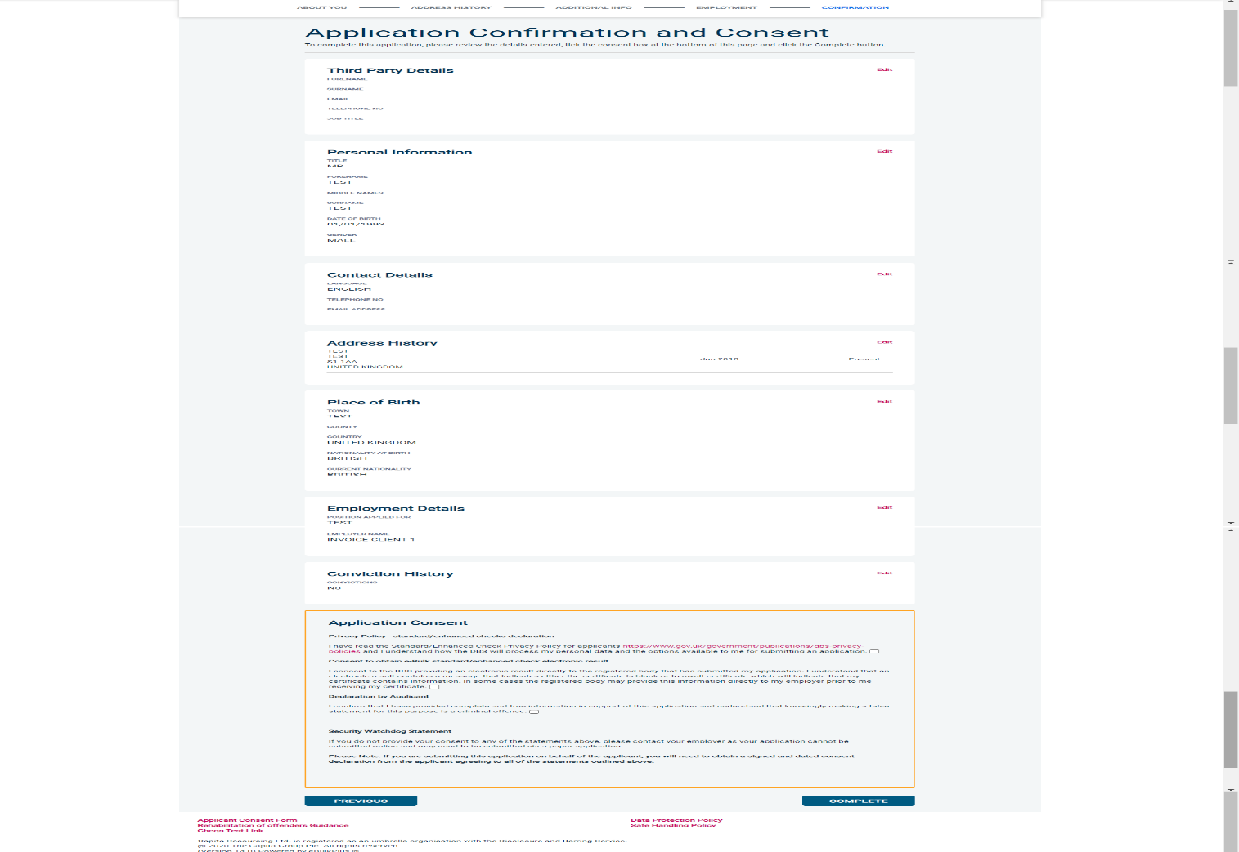

|  |
| --- |
| **Complete Application** |

You have now completed your application form and you will be given a submission reference number.

**Make a note of this number for reference purposes.** If you entered an email address onto your application form you will receive a confirmation email containing these details.

Remember to press **Exit button** as shown below.

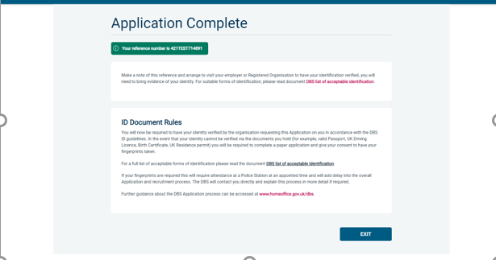

|  |
| --- |
| **Next step – identity verification** |

In line with the DBS code of practice all applicants requiring a DBS check must have their identity verified.

How do I have my identity verified?

Please contact your school/college/organisation directly to arrange an appointment for your original identification documents to be viewed and processed. A list of acceptable identity documents can be found on the next page of this guidance. Your application form will be processed by your employer once they have verified your identity before being sent on to the DBS.

|  |
| --- |
| Tracking the progress of your application with the DBS |

If you supplied an email address whilst entering your application, as soon as your application has been received by the DBS and is assigned a DBS Application Reference number you will receive a second email detailing this information. This email will also include details and links to the DBS website to enable you to track the progress of your application from the moment the disclosure process commences.

|  |
| --- |
| Contact Details |

Please contact your school/college/organisation if you have any queries with regards to the DBS application process. If you experience any technical issues with the online system, please contact our DBS team on 0800 073 4444 (option 3). Alternatively you can contact us by e-mail at [dbs@strictlyeducation4s.co.uk](mailto:dbs@strictlyeducation4s.co.uk).

|  |
| --- |
| **Providing Identity Documentation** |

The complete list of documents that may be accepted as proof of your identity, along with information on the number and types required can be found below. There are **three routes as outlined on the next pages;** however the registered body **strongly advises** that applicants should where possible produce documents which adhere to **Route 1** of the ID Checking process to avoid delays in the ID checking process.

|  |
| --- |
| **\*ID Document Rules** |
| * You must provide **original** documentation only; photocopies or documentation printed from the internet e.g. internet bank statements **will not** be accepted. * At least one document **must** confirm your **current name -** remember to also provide documentation to support any name changes e.g. Marriage/Civil Partnership Certificate * At least one document **must** confirm your **date of birth** * At least one document **must** confirm your **current address** together with evidence covering your previous five year address history. |

|  |
| --- |
| **Applicants who are not a national of the UK or the European Economic Area (EEA)** |
| If you want to do paid work and you are not a national of the UK or European Economic Area (EEA) you must be able to show:   * One primary document (refer to list of primary documents below) & * 2 supporting documents (from group 1, 2A or 2B)   If you cannot provide this documentation then a DBS check cannot be submitted as the right to work in the UK cannot be established. You cannot use any other route.  **If you want to do voluntary work and you are not UK or EEA nationals you must use Route 1**.  Non-EEA nationals who are eligible for a DBS check and receiving payment for work, even if it is an allowance, e.g. a foster carer, must use the paid work route.  However, Route 1 can be used by adult household members:   * in a fostering household * in a childminding household * in a host family * living where ‘work with children’ takes place e.g. living in a boarding school |
| **Primary Documents**  **Paid Non-EEA Nationals** |
| * A current Biometric Immigration Document (Biometric Residence Permit) issued by the Home Office to the holder indicating that the person named is allowed to stay indefinitely in the UK, or has no time limit on their stay in the UK. * A current Biometric Immigration Document (Biometric Residence Permit) issued by the Home Office to the holder which indicates that the named person can currently stay in the UK and is allowed to do the work in question. * A current Passport endorsed to show that the holder is exempt from immigration control, is allowed to stay indefinitely in the UK, has the right of abode in the UK, or has no time limit on their stay in the UK. * A current Passport endorsed to show that the holder is allowed to stay in the UK and is currently allowed to do this type of work question. * A Certificate of Application issued by the Home Office under regulation 17(3) or 18A (2) of the Immigration (European Economic Area) Regulation 2006, to a family member of a national of a European Economic Area country of Switzerland stating that the holder is permitted to take employment which is less than 6 months old together with a Positive Verification Notice from the Home Office Employer Checking Service. * An Application Registration Card issued by the Home Office stating that the holder is permitted to take employment in question, together with a Positive Verification Notice from the Home Office Employer Checking Service.   **Applicants providing one of the following documents must also provide a valid Passport:**   * A current Residence Card (including an Accession Residence Card or a Derivative Residence Card) issued by the Home Office to a non-European Economic Area national who is a family member of a national of a European Economic Area country or Switzerland or who has a derivative right of residence. * A current Immigration Status Document containing a photograph issued by the Home Office to the holder with a valid endorsement indicating that the named person may stay in the UK, and is allowed to do the type of work in question, together with an official document giving the person’s permanent National Insurance number and their name issued by a Government agency or previous employer. * A current Immigration Status Document issued by the Home Office to the holder with an endorsement indicating that the named person is allowed to stay indefinitely in the UK or has no time limit on their stay in the UK, together with an official document giving the person’s permanent National Insurance number and their name issued by a Government agency or a previous employer. |

|  |
| --- |
| **ROUTE ONE - All applicants must initially be considered via Route One.** |
| **ROUTE ONE** |
| For Route One, you **must** produce:   * one document from Group 1 * 2 further documents from either Group 1, or Group 2a or 2b   At least one of the documents must show your current address.  **If you’re not a national of the UK or the EEA and you’re applying for voluntary work you may need to be fingerprinted if you cannot show these documents**. |

|  |
| --- |
| **ROUTE TWO** |
| Route Two can only be used if it’s impossible to process the application through Route 1.  If you are not a national of the UK or the EEA and applying for voluntary work you cannot use Route 2.  If you do not have any of the documents in Group 1, then you must be able to show:   * 1 document from Group 2a; **and** * 2 further documents from Group 2a or 2b; one of which must verify your current address; * **and** **the organisation conducting the ID check will request an external ID validation check to be undertaken with your consent**.   **EEA nationals who’ve been resident in the UK for 5 years or less may need to be fingerprinted if you cannot show these documents.**  Note that if you are unable to provide a Group 1 document the school/college/organisation conducting the ID check will request that an external ID validation check is carried out to establish your name and living history footprint to meet DBS ID validation requirements via their registered body.  If you are unable to produce ID documentation to meet Group 2 requirements you will need to explain clearly the reasons for this to your school/organisation. You will then need to proceed to Route 3. |

|  |
| --- |
| **ROUTE THREE** |
| Route 3 can only be used if it’s impossible to process your application through Routes 1 or 2.  **EEA nationals who’ve been resident in the UK for 5 years or less cannot use Route 3**.  For Route 3, you must be able to show:   * a birth certificate issued after the time of birth (UK, Isle of Man and Channel Islands) and * one document from Group 2a and * 3 further documents from Group 2a or 2b   **At least one of the documents must show your current address. If you cannot provide these documents they you may need to have your fingerprints taken at a police station.** |

|  |  |
| --- | --- |
| **List of Valid Identity Documents** | |
| **Group 1 – Primary Trusted Identity Credentials** | |
| Current Valid Passport | Biometric Residence Permit (UK) |
| **A passport or biometric residence permit can only be used as a supporting document if it’s not already been used as a primary document.** | |
| Current Valid Driving Licence – **Photo card** - **UK/Isle of Man/Channel Islands and EEA (Full or provisional) All licences must be valid in line with current DVLA requirements** | Birth Certificate (**UK & Channel Islands**) - **issued within 12 months of birth** – full or short form acceptable including those issued by UK authorities overseas, such as Embassies, High Commissions and HM Forces |
| Adoption Certificate (UK & Channel Islands) |  |
|  | |
| **Group 2a – Trusted Government/State Issued Documents** | |
| Current Valid Driving Licence – **photo card (full or provisional) All countries outside the EEA (excluding Isle of Man/Channel Islands**  **All licences must be valid in line with current DVLA requirements** | Birth Certificate (**issued after time of birth)** UK & Channel Islands |
| Marriage/Civil Partnership Certificate (UK & Channel Islands) |
| Current Valid Driving Licence - **paper version**  **(if issued before 1998) UK/Isle of Man/Channel Islands and EEA (full or provisional) All licences must be valid in line with current DVLA requirements** | Immigration document, work permit or VISA (Issued outside of EEA) (Valid only for roles whereby applicant is living and working outside of UK.) |
| HM Forces ID Card (UK) | Fire Arms Licence (UK, Channel Islands & Isle of Man) |
|  | |
| **Group 2b – Financial/Social History Documents** | |
| Credit Card Statement * (UK or EEA) | Bank/Building Society Statement * (UK, Channel Islands or EEA) |
| Utility Bill* (UK) Not Mobile Telephone | Bank/Building Society Statement * (Countries outside the EEA) (Branch must be in the country where the applicant lives and works). |
| Document from Central/ Local Government/ Government Agency/ Local Authority giving entitlement (UK)*: e.g. from the Department for Work and Pensions, the Employment Service , Customs & Revenue, Job Centre, Job Centre Plus, Social Security | Bank/Building Society Account Opening Confirmation Letter (UK)* |
| Benefit Statement* - e.g. Child Benefit, Pension |
| Financial Statement ** - e.g. pension, endowment, ISA (UK) |
| Mortgage Statement (UK or EEA)** | Council Tax Statement (UK & Channel Islands)** |
| P45/P60 Statement (UK & Channel Islands) ** | EEA National ID Card (must still be valid) |
| Cards carrying the PASS accreditation logo (UK, Isle of Man & Channel Islands) – Must still be valid | Letter of Sponsorship from future employment provider (Non-UK/Non-EEA only) – Valid only for applicants residing outside of the UK at time of application |
| Letter from a Head Teacher or College Principal (UK) - 16/19 year olds in full time education (Only to be used in exceptional circumstances when all other documents have been exhausted). | |

**Please note if a document in the List of Valid Identity Documents is:**

* **Denoted with * - it should be less than three months old.**
* **Denoted with ** - it should be issued within the past 12 months.**

|  |
| --- |
| **What happens next?** |

After the school/establishment has checked your documents they will send the form electronically to be processed via Strictly Education 4S Ltd. Once DBS have completed the check they will issue a certificate which will be posted to your address.

**Please note that requests for reprints can only be made to the DBS within 93 days of the issue date of the certificate.**

**Where information is provided on the DBS certificate, you will be required to present your copy within 28 days of the issue date to your school/organisation.**

**The school/organisation process will be as follows:**

* They will be required to take a photocopy of your certificate
* Undertake an initial risk assessment
* You will be contacted by the designated person within the school/organisation, e.g. Headteacher/manager to arrange an appointment to discuss the content on your certificate.

**On the basis of a full risk assessment, the school/establishment will determine whether you are suitable to work/volunteer within their school/establishment and will inform you of their decision.**

|  |
| --- |
| **Disputing Information on a DBS Certificate** |

If you believe the information on your DBS certificate is incorrect, you must resolve this before the school/establishment can make a decision about your suitability. This can only be done by telephoning the DBS directly within **three months of the issue date** of the certificate using the telephone number listed on the back of the certificate under ‘disputes’.

**If it should prove impossible to resolve matters by other means, the DBS may seek a fingerprint check in order to determine whether the record in question relates to you.**

|  |
| --- |
| **DBS Update Service** |

Users of the online DBS application service will be given the opportunity to subscribe to the DBS update service on receipt of their electronic (e) reference number or when their new certificate is issued. **You only have** **30 days** **from the date of issue of your certificate** **in which to subscribe. The website address is** [**https://www.gov.uk/dbs-update-service**](https://www.gov.uk/dbs-update-service)**.** Subscribing to this service could mean that when you next change employer, and assuming that your new role is within the same workforce, where the same level and type of check are required, you will be able to give your new employer access to check online whether there has been any update to your DBS Certificate. This part of the pre-employment screening process will become quicker because the new employer will not have to complete a new DBS application for you, although the process will still enable them to comply with safeguarding rules. **Subscription is for 12 months, renewable annually at a cost of £13 per annum; for voluntary roles subscription is free.**

There is no statutory requirement for you to subscribe, and some organisations may decide that they wish their employees, volunteers or associates to subscribe, either on a voluntary or contractual basis. For individuals working in roles requiring more flexibility however, this service will prove to be extremely valuable.

|  |
| --- |
| **Data Protection:**  Strictly Education 4S Ltd has a policy on handling disclosure information which is followed by your school/establishment. Copies of these can be obtained from your school/establishment. |

|  |
| --- |
| **Further Information**  If you require support in completing your Online DBS Application, please contact the school/establishment in the first instance for further advice. |